# Exercises: Introduction to Databases

This document defines the **exercise assignments** for the ["Databases Basics - MSSQL" course @ Software University.](https://softuni.bg/trainings/1436/databases-basics-mssql-september-2016)

## Download and Install SQL Server Express

Download and install SQL Server. Do not install unneeded features of SQL Server.

### Task 1. Download SQL Server 2016 (Express or Developer edition)

Go to the Microsoft web site and download the SQL Server 2016 Express <https://www.microsoft.com/en-us/download/details.aspx?id=52679>

### Task 2. Install the SQL Server 2016

1. Open installation file and choose Installation section. Then click on the **“New SQL Server stand-alone installation…”**

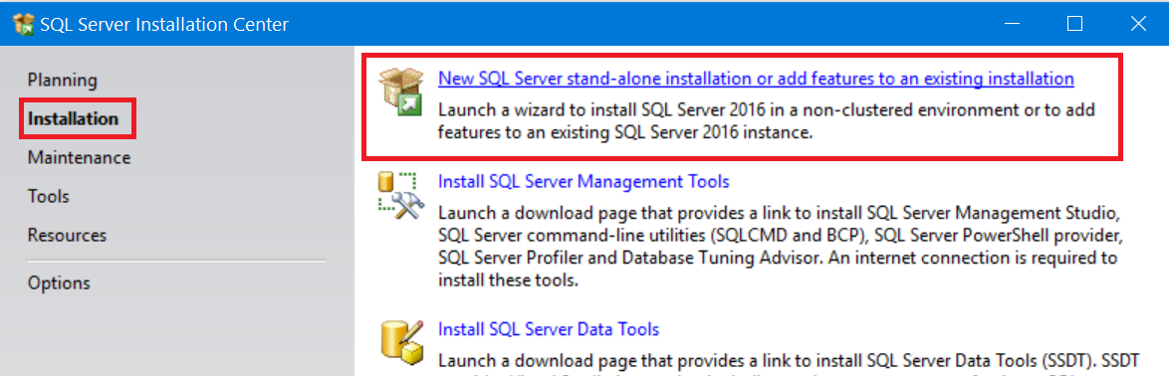

1. After a few clicks on the next button you should choose “**Installation Type**”. If you haven’t installed SQL Server, you should choose “Perform a new installation of SQL Server 2014”. The other option is when you want to add more features to your existing instance of SQL Server 2014. Click next.

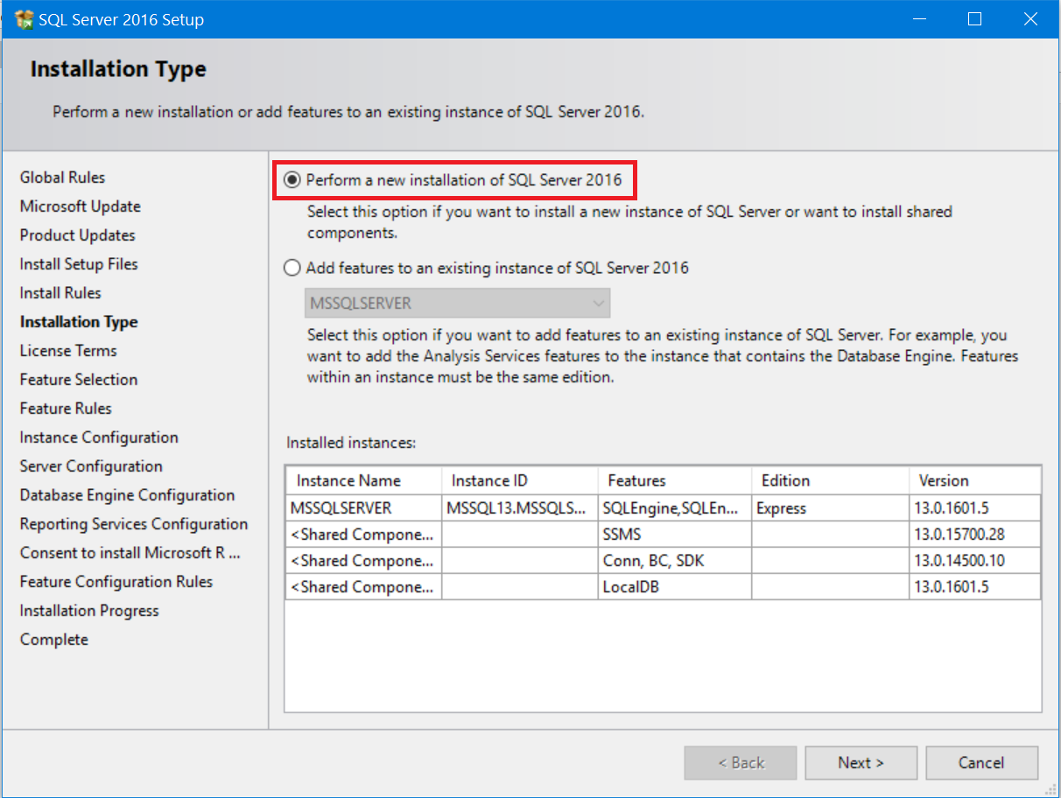

1. Probably in every installation in Microsoft world you should accept the license terms.

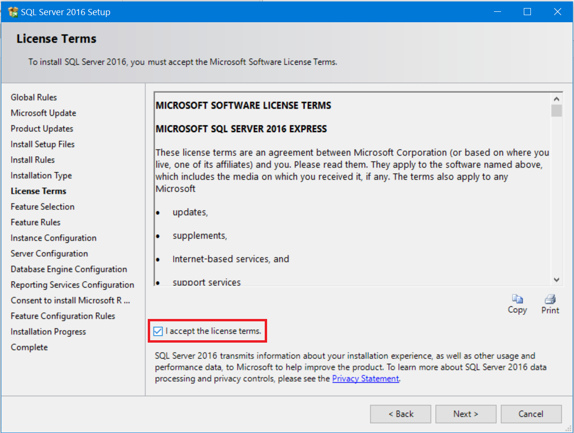

1. All features we need are **Database Engine Services.** Choose them and click next.

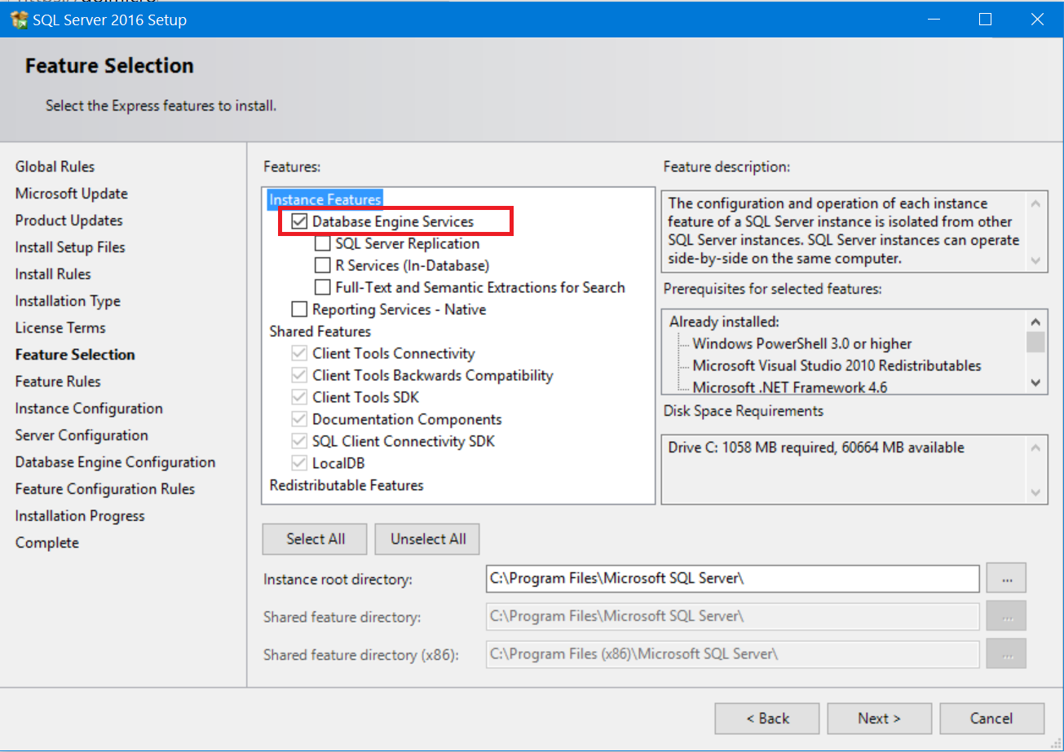

1. Choose **Default instance**. You can have only one default instance on one machine.

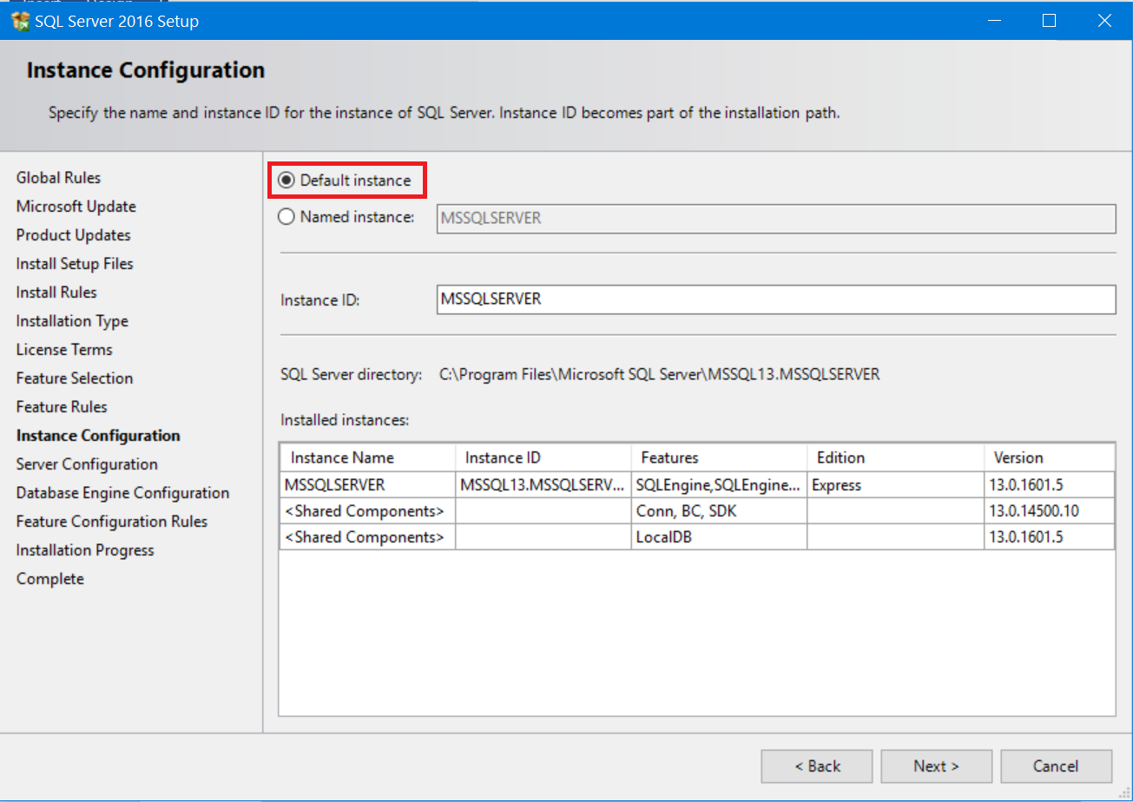

1. Here you can set the startup type of the services. Automatic mode starts them on Windows start. On Manual mode you should start them manually before use.

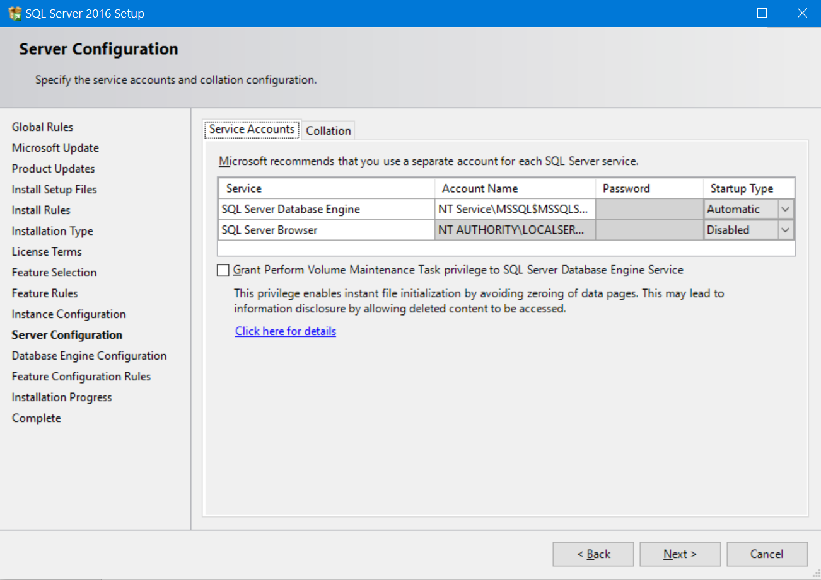

1. Here you can choose the **Authentication Mode.** Choose Windows authentication mode. You can change it later. Add your current user as system administrator account.

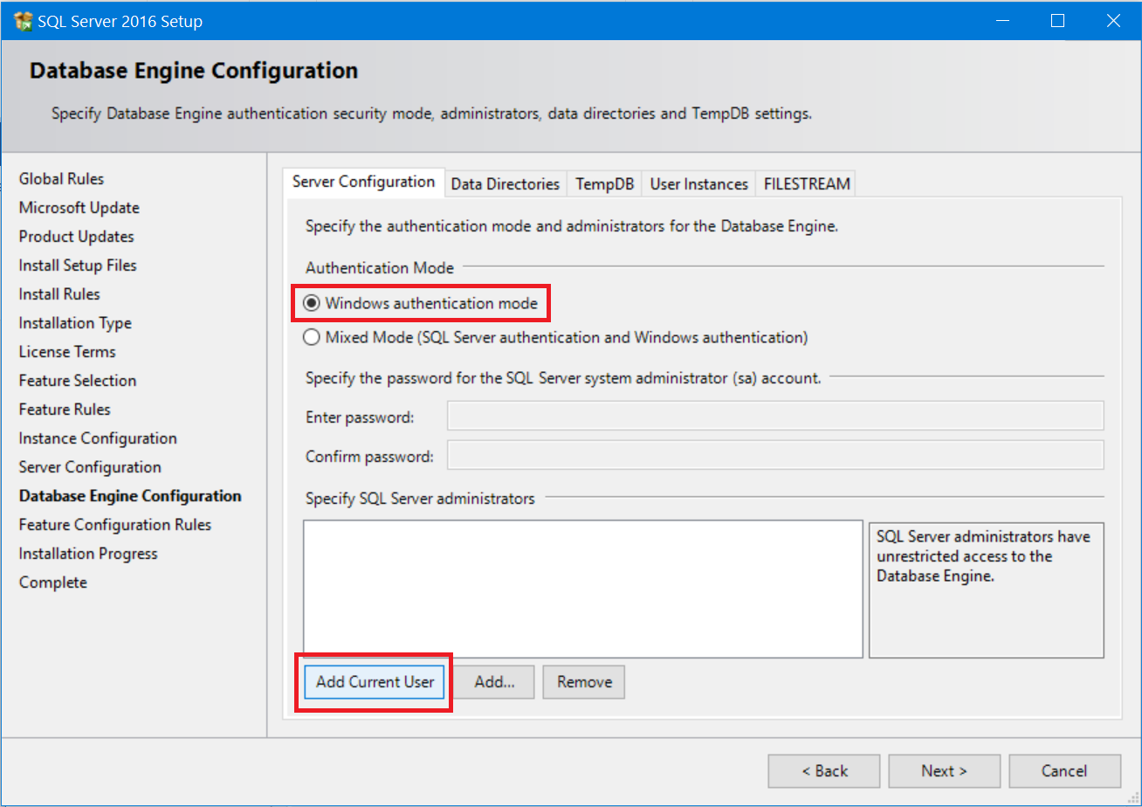

1. Click **Next >** to start the installation and wait until it finishes installing

## Download and Install SQL Server Management Studio

Go to the Microsoft web site and **download the SQL Server Management Studio** <https://msdn.microsoft.com/en-us/library/mt238290.aspx>. Then **install** it.

## Create New Database

* Connect to Server with Authentication Mode

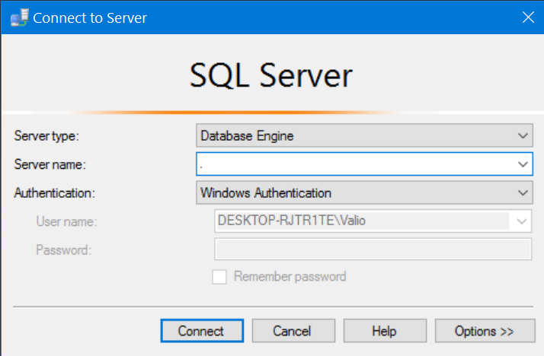

* Create a new database

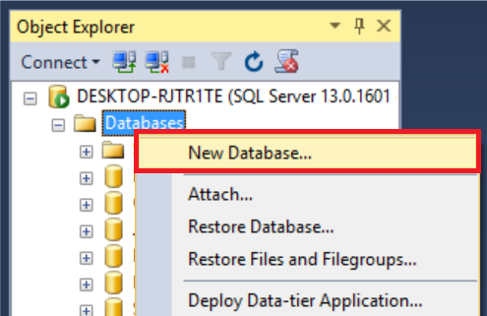

* Type the name of the database and click OK. This will create your database.

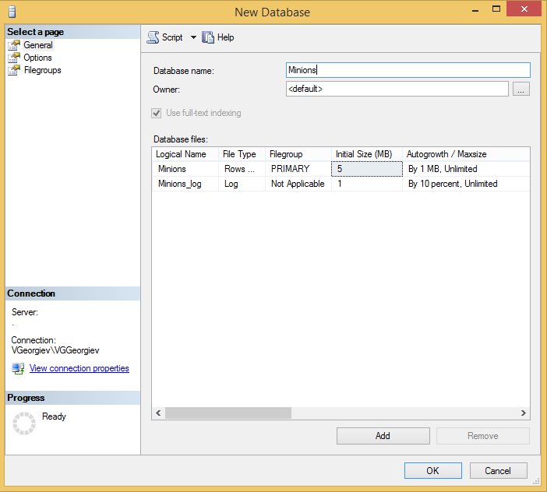

## Create Table

* Create **table** **Minions**

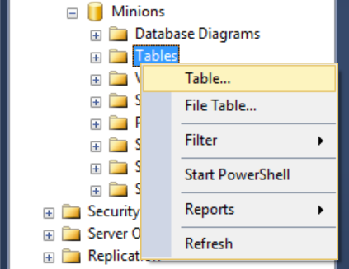

* Create columns **Id, Name, Age**. Id and Name are **required**; Age should **allow null values**.

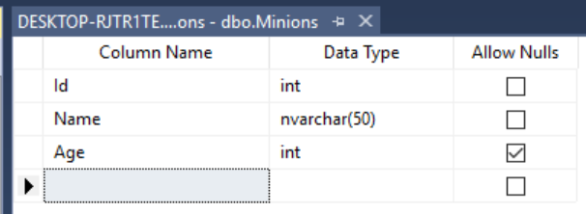

* Set the **Id** as **primary key**.

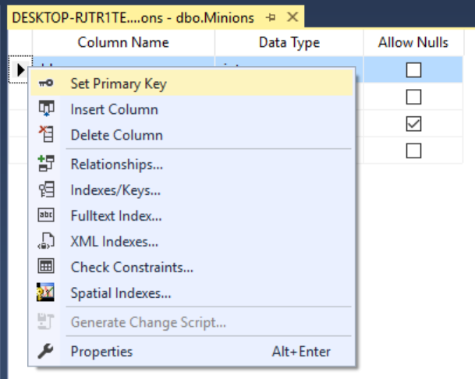

## Insert Data in the Table

Insert data in the table as its show on the picture

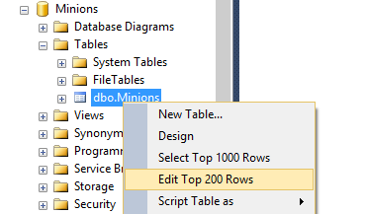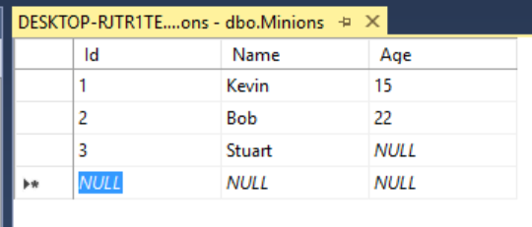

## Select Data from Table

* Select all columns from the Minions table.

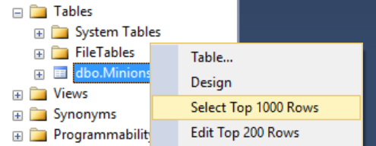

* Open new query window, then write the SQL.
  + * Select **only Names** from Minions table.
  + ** **Order** them **ascending by name**

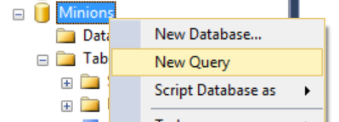

## Update One Record

Change **Stuart’s age** from **NULL** to **10**



## Update All Records

Change all of the Minions age to be + 1 years.

## Delete Record

Open table in the Edit Mode, **right click** on the row where **Bob** is situated and delete it.

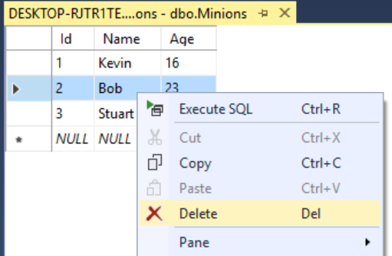

## Create New Table

Create new table **Towns**. Every town has **Id (int)** and **Name (text)**. Make the **Id** column **primary key**.

## *Connect Tables

Now let’s make a connection (or relationship) between our two tables. First we need modify our Minions table. Add column **TownId** in it **(IMPORTANT: The type of the column must be the same as the type of the column Id of the Towns table)**.

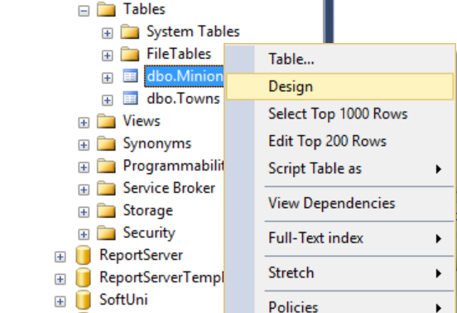

Now we can make new diagram. The diagram shows all tables and the relationships between them.

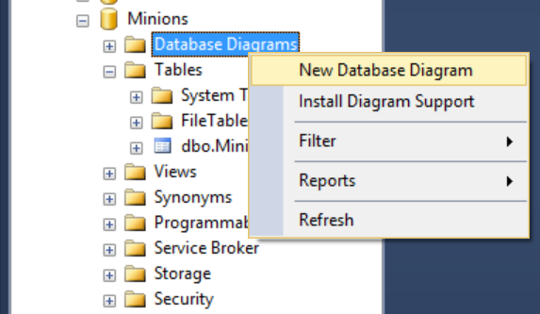

Select all tables to be on the diagram and click **Add**

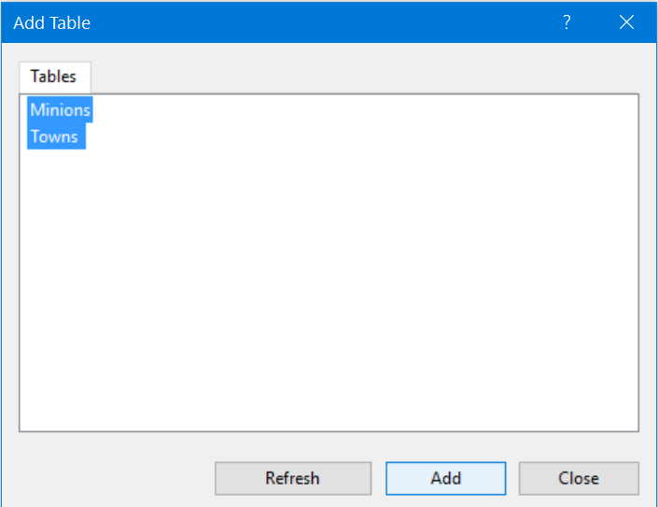

Finally, simply drag the **TownId** column and drop it on the Id column in Towns. Then Make sure the window looks like this and click OK.

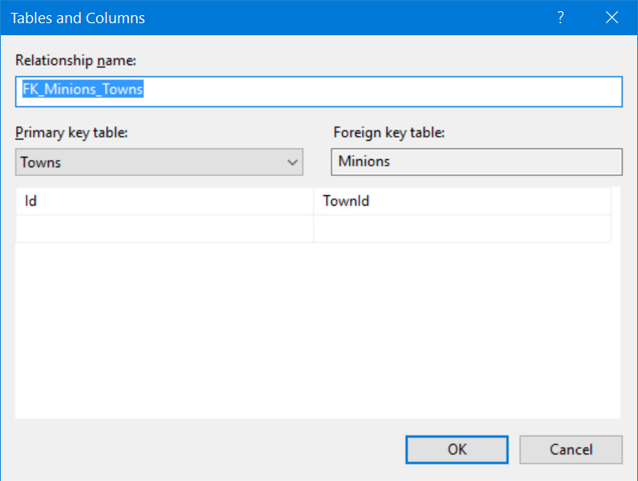

That’s all. No the two tables have a relationship between them.

## Create New Database

Now on your own create a new database **School**. Add a few tables to the database: **Students (Id, Name, Age, PhoneNumber)**, **Classes (Id, Name, MaxStudents), Teachers(Id, Name, Class)**. Add columns for the tables. Populate the tables with random content. Then delete and make changes in some records.

## *Generate SQL Script

Generate SQL script from the **School** database. View the script file and try to understand different commands. Execute the script.